CRIM 0367 - Credit Analyst Lobby

|  |  |  |  |  |
| --- | --- | --- | --- | --- |
| **Ver** | **Date** | **Author** | **Comments** | **Reviewed by** |
| 1 | 13/11/2020 | Tom Bell | CRIM 0367 | TBC |
|  |  |  |  |  |

Requirements 2

Prerequisites 2

Solution Overview 2

Solution Details 2

Security 3

Companies 3

Data Migration 3

Test Steps 3

Technical Implementation 3

Requirements

The system must provide a lobby that Credit Analysts can use to navigate to different parts of the system and work items.

Prerequisites

* CRIM 0343 for Creating Invoice Header Notes.
* CRIM 0392 for Creating Queries
* CRIM 0330 for Aging Buckets.
* CRIM 0333 for Sending of Partial Statement.

Solution Overview

**Context**: A Credit Analyst logs into IFS and their main work will be driven from this lobby. The lobby will have a filter at the top to filter by Credit Analyst. Once filtered the lobby is populated with only data relating to the Credit Analyst’s assigned Customers. The lobby will contain 17 lobby elements including tiles and charts that are listed below.

* Call List
* Overdue Debt
* Customer Payment on Account
* Blocked Customers
* Top 10 Customer Debt (By Aging Bucket)
* Top 10 Largest Items (By Aging Bucket)
* Items Escalated to Credit Manager
* Items in Query (Open)
* Items in Query (Overdue)
* Send Full Statement
* Send Partial Statement
* Large Invoice Courtesy Call
* Target Doughnut Chart
* Credit Limit for Review
* Credit Utilisation
* Legal Customer’s tile
* Escalated to Finance Controller

The below screenshot shows a rough design overview for the Credit Analyst Lobby.

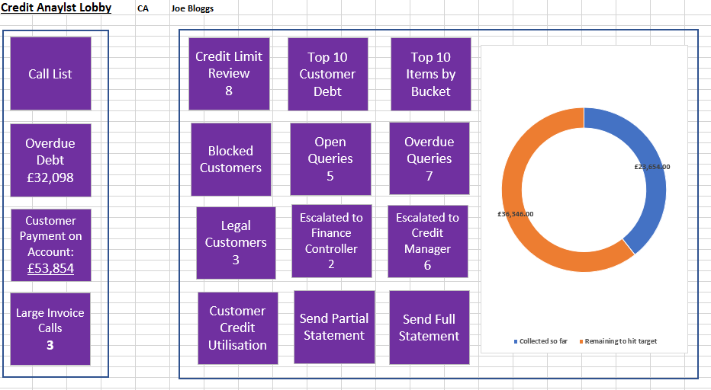

Solution Details

The below section details what functionality the Credit Analyst Lobby requires.

# Lobby Filter

A filter is required at the top of the lobby with a drop down to filter by Credit Analyst. The Credit Analyst can only filter by their own Credit Analyst user.

The below screenshot shows an IFS stock Credit Management lobby. The red box shows where a filter needs to be placed to filter by Credit Analyst, once this filter is populated the lobby will only be populated with customers and data relevant to that Credit Analyst.

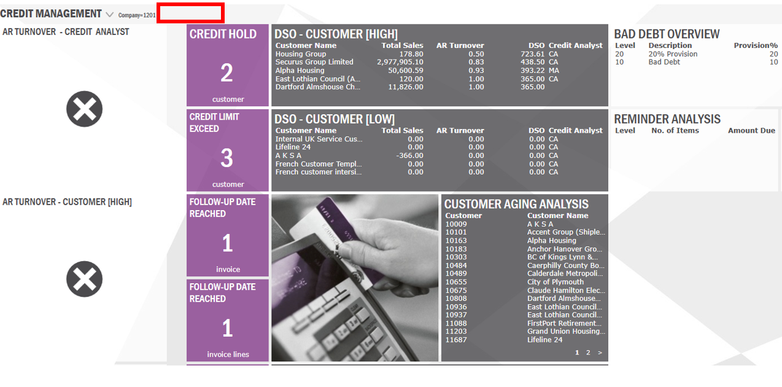

# Call List Tile (Customer Credit Analysis Screen)

Clicking into this tile will bring the Credit Analyst to the Customer Credit Analysis Screen. A title is needed at the top of this Screen named “Call List”.

By clicking into this tile from the Credit Analyst Lobby, the Credit Analyst is brought to the “Customer Credit Analysis” screen with a saved search that filters only Customers assigned to that Credit Analyst.

Conditional formatting must be applied to this screen to only show Customers where the most recent Invoice Header Credit Note “Follow Up Date” is equal to or older than today’s date. (Older notes will be ignored).

The Call List screen must include Customers that have no Invoice Header Credit Notes attached to them.

**Call List Conditional Formatting/Filter Summary:**

* Filter the Call List to only show Customers where the most recent Invoice Header Credit Note “Follow Up Date” is less than or equal to the current date and there is overdue debt on the item
* Filter the Call List to show Customers that have no Invoice Credit Notes attached to them and have overdue debt on the account.
* Filter list to exclude customers where the most recent Invoice Header Credit Note has a Note status of: “Note Status 1 – Complete” or “Note Status 2 – Escalated to Credit Manager” and with No Open Items on their account (any customer with an item(s) that is not in Aging Bucket - Current).

**Example**

The below screenshot shows the Invoice Header Note screen for a customer. Today’s date is the 17/11/2020. This customer item will be filtered out of the Call List as the most recent Note is not due for a Follow Up until the 19/11/2020.

On the date 19/11/2020 this Customer will appear in the Call List screen as the Follow Up Date on this Invoice Header has been reached and the Note(s) must be updated.

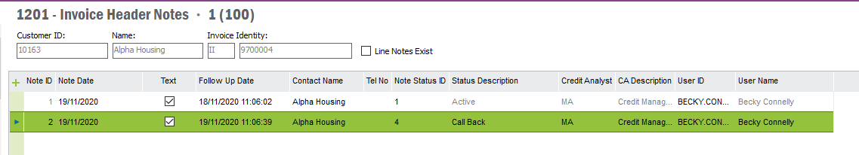

The below screenshot shows that the latest Note Status for this item has now been set to “Complete”. This customer and item will be excluded from the Call List screen.

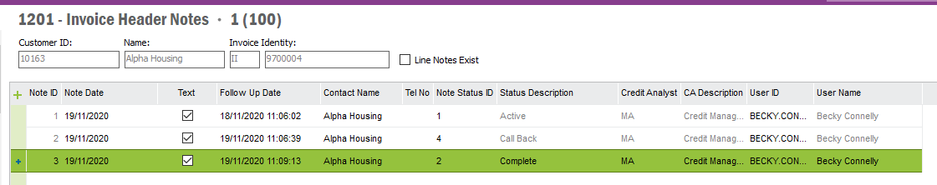

The below table lists the Note Statuses and whether the Call List filter should include these items or not.

**Note Status Inclusion List**

|  |  |  |
| --- | --- | --- |
| **Note Status ID** | **Status Description** | **Include in Call List** |
| 1 | Complete | NO. |
| 2 | Escalated to Credit Manager | NO. |
| 3 | Credit Manager Resolved | YES. |
| 4 | Cheque in Post | YES. |
| 5 | Payment Promise | YES. |
| 6 | BACS/Remit Received | YES. |
| 7 | Additional Comment | YES. |
| 8 | Copy Invoice Requested | YES. |
| 9 | Message Left | YES. |
| 10 | 7 Day Letter | YES. |
| 11 | Credit Balance | YES. |
| 12 | Payment Certificate Received | YES. |
| 13 | Incoming Call | YES. |
| 14 | LA Cash | YES. |
| 15 | Legal | YES. |
| 16 | Outgoing call/email | YES. |
| 17 | Statement Requested | YES. |
| 18 | Proforma | YES. |
| 19 | In Query | YES. |
| 20 | Request Customer Block | YES. |
| 21 | Escalated to Finance Controller | NO. |
| 22 | Finance Controller Resolved | YES. |

**Additional Column Requirements in Call List (Customer Credit Analysis Screen)**

* Largest Overdue Debt
* Oldest Overdue Debt
* Follow Up Date (Of oldest Invoice Header Note)

|  |  |
| --- | --- |
| **Column Name** | **Column Data Description** |
| Largest Overdue Debt | Largest item that is overdue amount. |
| Oldest Overdue Debt | Oldest Item that is overdue amount. |
| Follow Up Date | Oldest follow up date on the most recent Invoice Header Note for an outstanding item. |

# Overdue Debt Tile (Customer Credit Analysis Screen)

By clicking into this tile, the Credit Analyst is brought to the Customer Credit Analysis screen with a saved search that only shows customers linked to that Credit Analyst with overdue debt on their account (any customer who’s item(s) that are not in Aging Bucket – Current).

Additional, columns are required for this screen include:

|  |  |
| --- | --- |
| **Column Name** | **Column Data Description** |
| Largest Overdue Debt | Largest item that is overdue amount. |
| Oldest Overdue Debt | Oldest Item that is overdue amount. |
| Follow Up Date | Oldest follow up date on Customer Credit Management Notes for an outstanding item. |

A title is needed on this screen named “All Overdue Debt” where the red box is on the screenshot below.

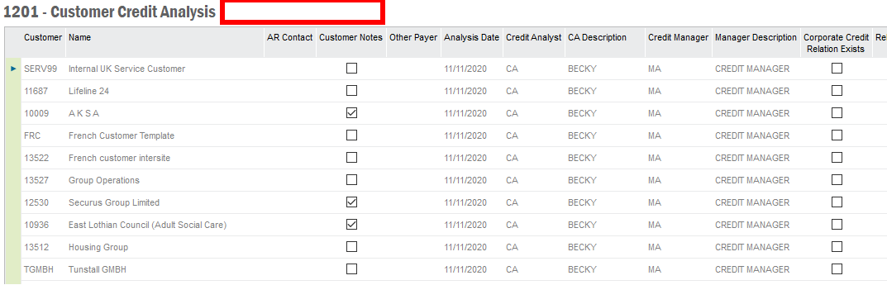

# Top 10 Total Customer Debt (Per Aging Bucket)

This tile will show a screen that has the Largest Customer Debt by Aging Bucket. Customer Number, Customer Name and Balance in Bucket as column headers and customer debt as rows. Sorted by largest customer balance descending. Only Customers would appear there that are assigned to the Credit Analyst.

The below screenshot shows a rough example of the tile content that is required.

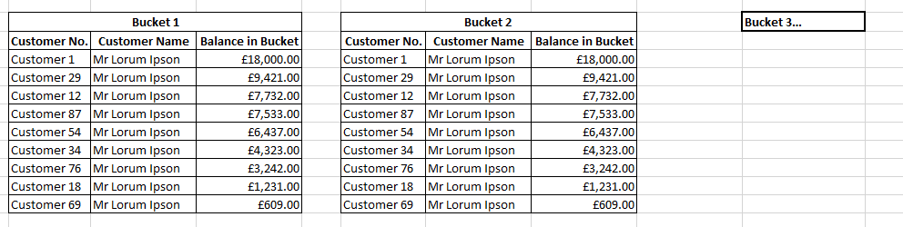

From this element an RMB on an item will show the same RMB options as the Customer Credit Analysis screen. See the below screenshot.

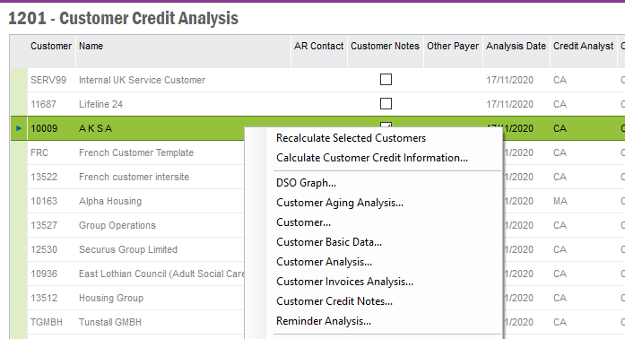

# Top 10 Items (Per Aging Bucket)

This tile will show the largest overdue debt by invoice amount. Sorted by largest open item. This screen would only show Invoices that belong to a Customer that is assigned to the Credit Analyst.

Aging Buckets as columns and invoices as rows.

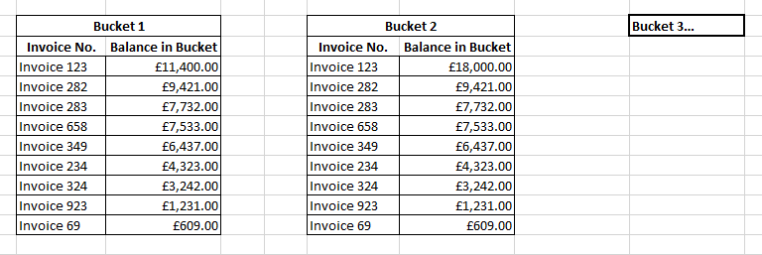

From this screen an RMB on an item will show the same RMB options as RMB on an invoice from the Customer Analysis (Ledger Tab) screen. The below screenshot shows the RMB options that are required from the Top 10 Items by Aging bucket screen when RMB on an item.

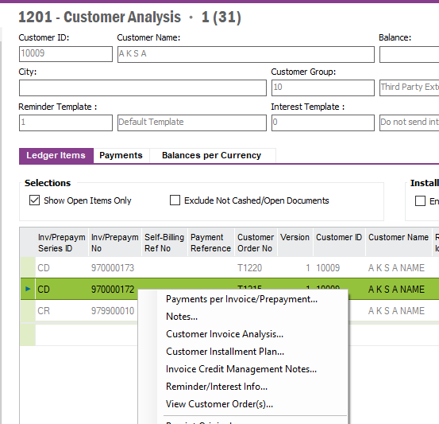

# Blocked Customer Tile

This tile lists the Customers that are assigned to the Credit Analyst that have been blocked. The Credit Blocked indicator is on the Customer Master Record (see red box in below screenshot). This is subject to the Credit Analyst filter within the lobby.

This tile will navigate to the Customer Credit Management screen and be filtered to only shows Blocked Customers on this screen.

The below screenshot shows the Customer data screen where the “Credit Blocked” button that would trigger the customer appearing in the Blocked Customer tile described above.

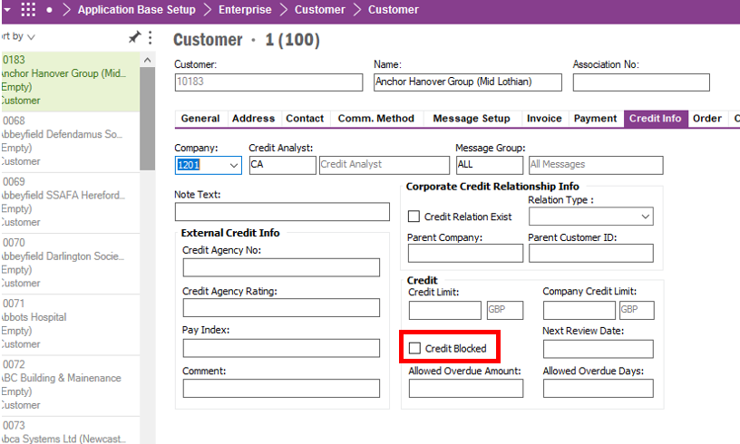

No decision has been made by the Business as to who has authority to grant Customer Blocking. 25/11/2020.

# Customer Payment On Account

Require a Tile called “Customer Payment on Account”. Within this Tile the Customer Analysis screen will be shown with a filter applied to the list to only show customers with Customer Payments on Account.

Require a filter on the Customer Analysis Screen that only shows customers with “Invoice Prepayment Series ID” = CUPOA (Customer Payment on Account) that is not zero for Open Amount.

Require a title at the top of this screen that reads “Customer Payment On Account”. On the tile from the lobby, the Tile will show the total Customer Payment on Account for Customer’s assigned to the Credit Analyst with Payment ID CUPOA. The below screenshot shows a rough example of what the tile could look like from the lobby.

The total Open Amounts for Customer Payments on Account should appear in the tile from the lobby as shown below.

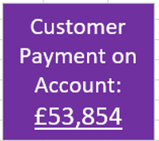

The below screenshot shows the Customer Analysis screen with an example customer with the Invoice Series ID CUPOA (in red box).

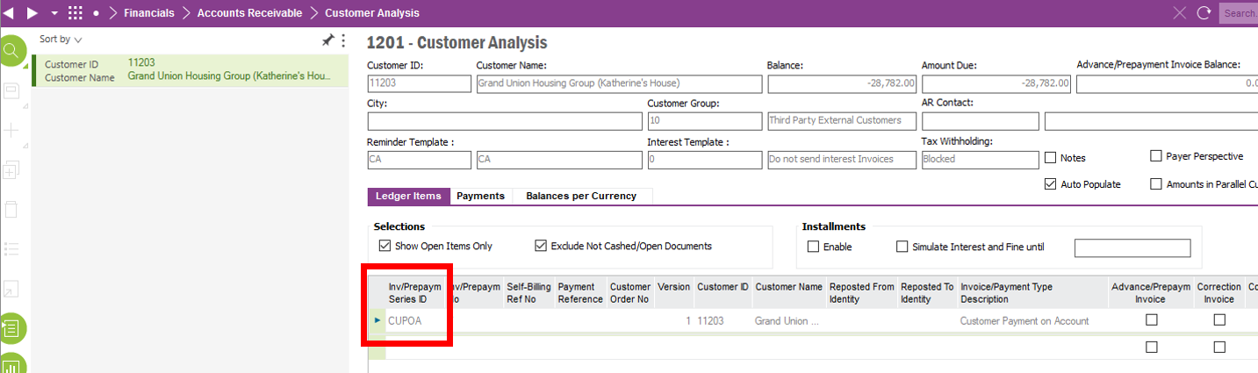

# Escalated Items Tile

By clicking into this tile, the Credit Analyst is brought to the Customer Credit Analysis screen.

Here this screen needs to be filtered to only show Customers who have items that have “Status 2 – Escalated to Credit Manager” Invoice Header Notes as the most recent Credit Note. This gives the Credit Analyst a view of what is currently being worked on by the Credit Manager.

From the lobby the tile should show the total of invoices that have the most recent note status set to the “Note Status 2 - Escalated to Credit Manager”.

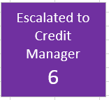

# Open Queries Tile (in time allowed)

Screen for showing items in query, where business owners need to rectify Queries on invoices. This screen needs to show the Customer Credit Analysis screen that has been filtered to only show customers with the latest Note Status 19 set to “In Query”, the Follow Up Date is after today’s date and the item is unpaid.

The below screenshot shows the tile that is required. The number of items in query that are open (not overdue) should be shown on this tile (“Note Status – In Query” & Follow Up Date after today’s date).



**Conditional Formatting/Filter:**

* Filter to only show customer with the latest Invoice Credit Header Note status set to “In Query”, the Follow Up Date is after today’s date and the item is unpaid.
* Filtered to only show Credit Analysts customers

# Overdue Queries (Overdue Queries)

Screen for showing items in query, where business owners need to rectify Queries on invoices. This screen needs to show the Customer Credit Analysis screen that has been filtered to only shows customers with the latest Note Status set to “In Query”, the follow up date before today’s date and the item is unpaid.

The below screenshot shows the tile that is required. The number of items in query that are overdue should be shown on this tile (“Note Status – In Query” & Follow Up Date before today’s date).

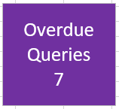

**Conditional Formatting/Filter:**

* Filter to only show customer with the latest Invoice Credit Header Note status set to “In Query”, the follow up date before today’s date and the item is unpaid.
* Filtered to only show Credit Analysts customers

# Ad Hoc Sending of Send Full Statement Tile

When clicking this tile, a dialogue box opens that asks for the Customer Name. Once confirmed the Customer Name/Number, the Credit Analyst would select “Send Statement” which would open the Customer Statement of Account report generation dialogue box as shown below. With the Full Statement of Account report attached.

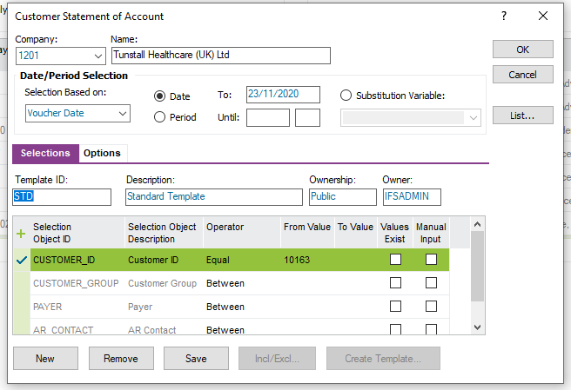

After confirming the options in the above parameters, the Credit Analyst will select “OK” and the below dialogue box would open.

Here the selected Customer’s email address would auto-populate (with the ability to manually input an email is require - editable). Selecting “OK” would send the statement to the customer via email.

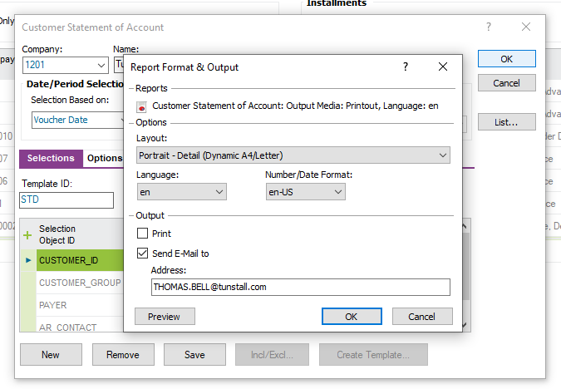

# Ad Hoc Sending of Partial Statement Tile

When clicking this tile, a dialogue box opens that asks for the Customer Name. Once confirmed (the Customer (Name/Number), this navigates to the Customer Analysis screen for that Customer. From here the normal Sending of Partial Statement process would be followed (CRIM 0333).

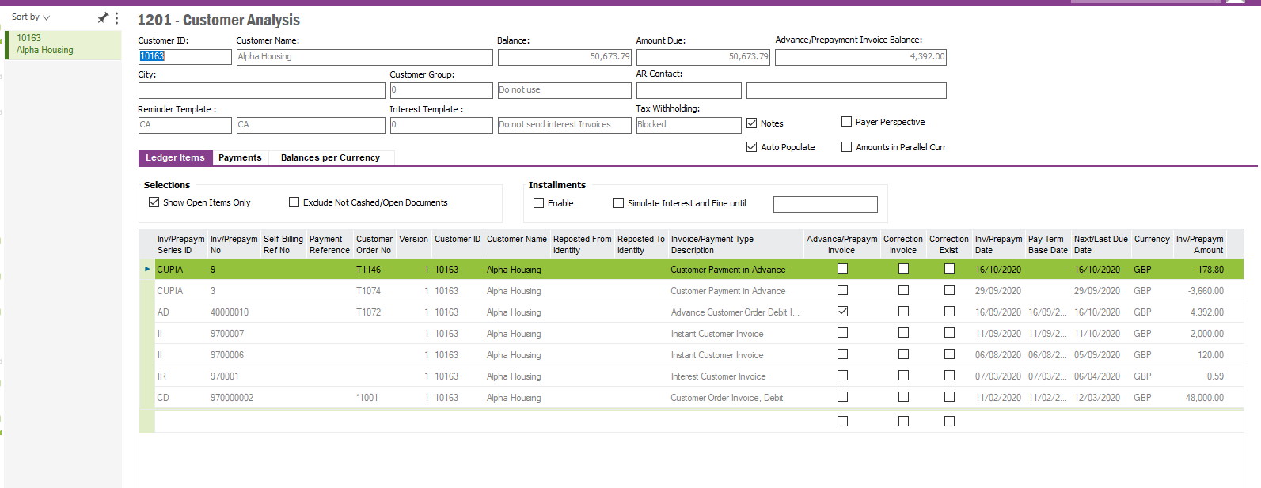

# Targets Doughnut Chart

A doughnut chart is needed from the lobby that shows how much cash that Credit Analyst has collected as well as the cash that needs to be collected for the Credit Analyst to hit their target.

* **Cash Collected** – Cash Collected by Credit Analyst for that calendar month.
* **Remaining to Hit Target** – (Monthly Target – Cash Collected) = Remaining

The Target basic data is described in CRIM 0368 for the Credit Manager’s lobby. This data will be located a new tab called “Credit Targets” in the Credit Management Basic Data screen.

The below chart shows an example of what is required.

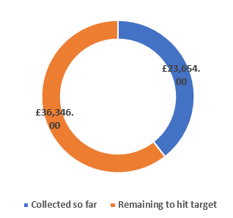

# Largest Invoice Courtesy Call.

By clicking into this tile, the user is brought to a Customer Credit Analysis screen where customers with unpaid invoices of £10,000 or above are shown for that Credit Analyst.

The below screenshot shows an example of the tile that is required. The number of Large Invoices is shown here.

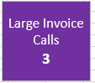

**Conditional Formatting/Filtering:**

* Customer with an unpaid invoice over £10,000 and assigned to that Credit Analyst.

# Customer Credit Usage Screen

This screen will show the Customer Credit Analysis screen with the same column headers as the Call List screen. This screen will be sorted by the column “Credit Limit Usage %” descending. The customer’s who’ve used the most Credit will be at the top of this screen.

The below screenshot shows an example of what this tile should look like from the Lobby. The number below the text is the “Number of Customer’s whose credit Utilisation is 95% or over”. This will give the Credit Analyst a good way to track customers who are nearing the max of their limit.

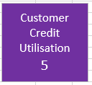

**Conditional Formatting/Filtering:**

* Filter by Credit Analyst lobby (Current Credit Analyst).

**Extra Columns in Credit Usage screen**

* **Customer Credit Limit Total –** Total Credit Limit on customer account
* **Customer Credit Limit Usage –** How much credit the customer has current used.
* **Credit Limit Usage % -** What % of their Credit limit has the customer used?
* **(From Call List screen)** Largest Overdue Debt
* **(From Call List screen)** Oldest Overdue Debt
* **(From Call List screen)** Follow Up Date (Of most recent Invoice Header Note)

# Credit Limit Due for Review.

When clicking into this tile, the Customer Credit Analysis screen is opened. This screen will show Customers assigned to that Credit Analyst and who’s credit limit has not been changed for 11 months or more.

**Context**: Credit Limits need updated every 11 months. This screen will log which customers need their credit limits updating.

From the lobby the tile must show the number of customer’s whose credit limit has not been updated for 11 months or more. In the below screenshot, this number of customers is 8.

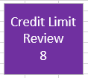

Columns)

* **Customer Credit Limit Total –** Total Credit limit on customer account
* **Customer Credit Limit Usage –** How much credit the customer has current used.
* **Credit Limit Usage % -** What % of their Credit limit has the customer used?
* **Last Credit Limit Update –** Date the Credit Limit was last updated.
* **(From Call List screen)** Largest Overdue Debt
* **(From Call List screen)** Oldest Overdue Debt
* **(From Call List screen)** Follow Up Date (Of most recent Invoice Header Note)

**Conditional Formatting/Filtering:**

* Filter by customers assigned to the Credit Analyst.
* Filter by Customer’s whose Credit Limit has not been updated for 11 months or more.

The Screenshot below shows where the Credit Analyst will input a new Credit Limit on the Customer record. This is the field that needs updating every 11 months.

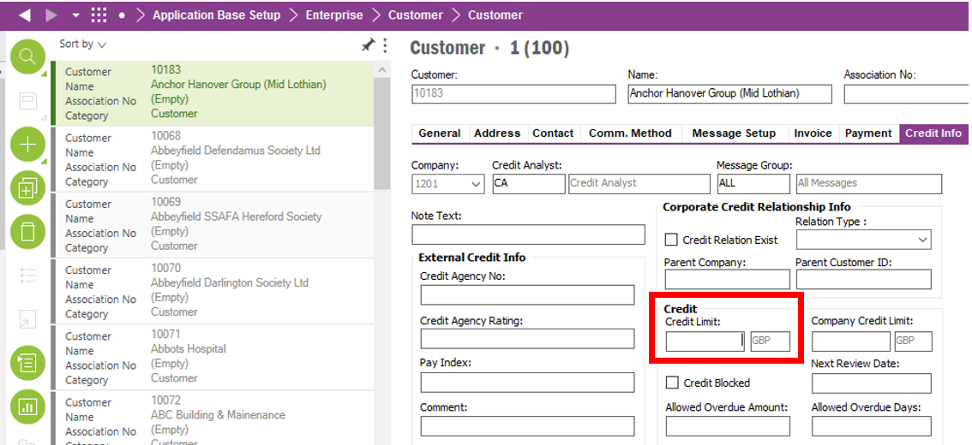

# Legal Customers Tile

By clicking into this tile, the Credit Analyst is brought to a Call List screen (Customer Credit Analysis screen) that is filtered to only show customers with the latest Note Status 15 “Legal”. These are customer who have not paid, and AR have passed their details over to Solicitors.

The below screenshot shows the tile as viewed from the Lobby screen. The number on the tile is the number of customers with latest Invoice Header Credit Note Status 15 “Legal”.

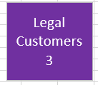

**Conditional Formatting/Filter:**

* Filter to only show customers with the latest Invoice Credit Header Note status set to “Note Status 15 – Legal”.
* Filtered to only show Customer who are assigned to that Credit Analyst.

# Escalated to Finance Controller Tile

By clicking into this tile, the Credit Analyst is brought to the Customer Credit Analysis screen.

Here this screen needs to be filtered to only show Customers who have items that have “Status 21 – Escalated to Finance Controller” Invoice Header Notes as the most recent Credit Note. This gives the Credit Analyst a view of what is currently being worked on by the Finance Controller.

**Conditional Formatting/Filtering.**

* Filter to only show customers who have the most recent Invoice Credit Header Note set as “Note Status 21 - Escalated to Finance Controller”.
* Filter to only show Customer’s assigned to the Credit Analyst.

From the lobby the tile should show the total of invoices that have the most recent note status set to the “Note Status 21 - Escalated to Finance Controller”.

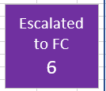

# Technical.

Field Definitions.

<New Field/CLU Definition>

|  |  |  |  |  |  |  |
| --- | --- | --- | --- | --- | --- | --- |
| New DB Object Name | DB Object Item/Field Names | Item Description | Item Data Type | Item Syntax | Calculation Spec, if Derived | LOVs/Enums/Is Mandatory? |
|  |  |  |  |  |  |  |
|  |  |  |  |  |  |  |
|  |  |  |  |  |  |  |
|  |  |  |  |  |  |  |
|  |  |  |  |  |  |  |
|  |  |  |  |  |  |  |
|  |  |  |  |  |  |  |
|  |  |  |  |  |  |  |
|  |  |  |  |  |  |  |
|  |  |  |  |  |  |  |
|  |  |  |  |  |  |  |
|  |  |  |  |  |  |  |

Security

<Define security controls> (Who needs access to this and will it be restricted from any other users etc)

|  |  |
| --- | --- |
| **Role** | **Permissions** |
| Finance Manager | All. |
| Credit Manager | All. |
| Credit Analyst | View other Credit Analyst lobbies.  Only edit their own Credit Analyst lobbies. |

Companies

Applies to the following companies. All.

|  |  |
| --- | --- |
| **Company** | **Required (Y/N)** |
| 1201 | Y |
| TBC |  |
|  |  |

Data Migration

<Describe any data migration impacts this development may have – i.e additional data to be migrated>

Test Steps

<Steps that needs to be taken to test this change. Please provide expected results> Updated post solution.

|  |  |  |
| --- | --- | --- |
| **No** | **Script\Test Steps** | **Expected Result** |
| 1 | Run “Credit Analyst Lobby” | See the required tiles and be able to filter lobby by Credit Analyst by a drop-down list. |
| 2 | Click Call List Tile | Navigated to Customer Credit Analysis screen with predetermined saved searches.   * Filtered to show customers whom have Invoice Header Notes that have a Follow Up Date older than or equal to today’s date. * Filtered the Call List to show Customers that have no Invoice Credit Notes attached to them. * Filtered list to exclude customers where the most recent Invoice Header Credit Note has a Note status of: “Note Status 1 – Complete” or “Note Status 2 – Escalated to Credit Manager”. |
| 3 | Click into Overdue Debt Tile | See the Customer Credit Analysis screen with all the Credit Analyst’s customers in the screen who have open items. |
| 4 | Click into Customer Payment on Account Tile | See a Tile called “Customer Payment on Account”. Within this Tile Customer Analysis screen will be shown with a filtered applied to the list to only show customers with Customer Payments on Account. Tile will have the amount of COPOA on it from the lobby. |
| 5 | Click into Top 10 Customer Debt Tile | See a screen that has the Largest Customer Debt by Aging Bucket. Customer Number, Customer Name and Balance in Bucket as column headers and customer debt as rows |
| 6 | Click into Top 10 Largest Items Tile | See a screen showing the largest overdue debt by invoice amount for only Items relating to that Credit Analyst. |
| 7 | Blocked Customer Tile | See a list of the Customers that are assigned to the Credit Analyst that have been blocked |
| 8 | Click into Items Escalated to Credit Manager | Screen will be filtered to only show Customers who have items that have “Status 2 – Escalated to Credit Manager” Invoice Header Notes as the most recent Credit Note. |
| 9 | Click into Items In Query (Open) Tile | Screen will be filtered to only show Customers who have items that have “Status 2 – Escalated to Credit Manager” Invoice Header Notes as the most recent Credit Note and the Follow Up Date is more than today’s date. |
| 10 | Click into Items In Query (Overdue) Tile | Screen will be filtered to only show Customers who have items that have “Status 2 – Escalated to Credit Manager” Invoice Header Notes as the most recent Credit Note and the Follow Up Date is less than or equal to today’s date. |
| 11 | Send Full Statement tile | Clicking this tile will open a dialogue box that allows a user to select a customer. After selecting the customer, a dialogue box opens with the report parameter settings. The Full Statement of Account Report is auto populated here as is the customer’s email address. |
| 12 | Send Partial Statement tile | Clicking this tile will open a dialogue box that allows a user to select a customer. After selecting the customer, the Customer Analysis screen is opened with that customer populated. |
| 13 | Large invoice Courtesy Call | A Customer Credit Analysis screen is opened with customer who have unpaid invoices on their account over £10,000. |
| 14 | Target Doughnut Chart | A chart on the lobby screen that shows the current collected amount by that Credit Analyst for the month and the amount they must collect to hit their target for that month. |
| 15 | Customer Credit Usage | Clicking into this screen will show the Customer Credit Analysis screen and will have extra columns such as Credit % utilisation and be sorted by this column descending, with the number of customers at 95% of their Credit Limit. |
| 16 | Credit Limit Due for Review | Clicking into this tile will have a filtered Customer Credit Analysis screen that only shows customers whose credit limits have not been changed for 11 moths or more. Along with the extra columns required. |

Technical Implementation

<Completed by the technical developer - Technical solution, list packages, functions, Custom menus created etc >

# Delivery Notes

1. Grant permissions to **‘Tunstall Credit Analyst’** lobby and two secondary drill down lobbies - **‘Top 10 Items by Bucket’**, **‘Top 10 Total Customer Debt’**

Permission sets: IFS_ALL, FND_QUICK_REPORTS

1. Lobby parameters:

* Company
* Credit Analyst
* Target Period (MM-YYYY format ex: 05-2021 for May 2021)

1. Import the ACP for C0367 (ACP Finance) and publish it.
2. Reload configuration on **‘Credit Management Basic Data’** screen to make **‘Credit Targets’** tab available and arrange the column order.
3. If the custom columns are not visible in ‘Customer Credit Analysis’ screen please do Reload Configurations, and use ‘Column Chooser’ to add them to the screen.

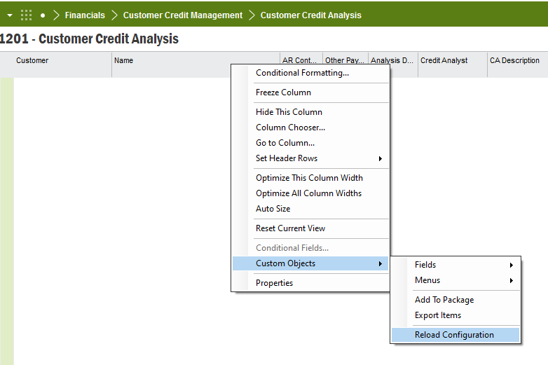

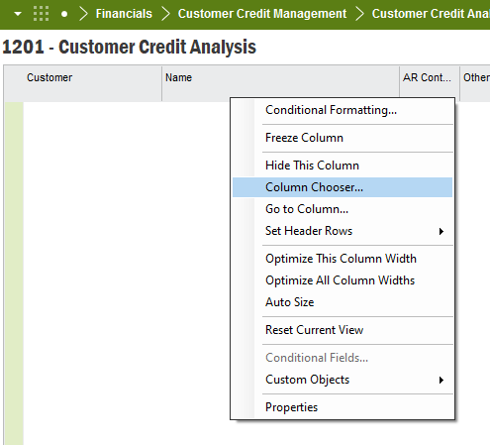

Custom Columns introduced from this CRIM:

* **Customer Credit Limit Total**
* **Customer Credit Limit Usage**
* **Credit Limit Usage %**
* **Largest Overdue Debt**
* **Oldest Overdue Debt**
* **Follow Up Date (Of most recent Invoice Header Note)**

1. Lobby elements

|  |  |  |  |
| --- | --- | --- | --- |
| **Element name** | **IAL** | **Custom Function** | **Remarks** |
| Call List |  | C_EA_Customization_Util_API.Check_Inv_Header_CA() | As there can be multiple invoices for the customer, each invoice should be considered in filter logic. So, the customer can get filtered if one of its invoices satisfy either one of the conditions.  Ex: Invoice 1 is satisfying condition 1 🡪 filtered to Call List  Invoice 2 is satisfying condition 2 🡪 filtered to Call List  Invoice 1 may not satisfy condition 2 and 3 |
| Overdue Debt |  |  |  |
| Top 10 Total Customer Debt | C_CUST_DEBT_PER_BUCKET1, C_CUST_DEBT_PER_BUCKET2, C_CUST_DEBT_PER_BUCKET3, C_CUST_DEBT_PER_BUCKET4, C_CUST_DEBT_PER_BUCKET5, C_CUST_DEBT_PER_BUCKET6 |  | Added as a secondary drill down lobby screen  Lobby name: Top 10 Total Customer Debt |
| Top 10 Items (Per Aging Bucket) | C_INV_PER_BUCKET1,  C_INV_PER_BUCKET2,  C_INV_PER_BUCKET3,  C_INV_PER_BUCKET4,  C_INV_PER_BUCKET5,  C_INV_PER_BUCKET6 |  | Added as a secondary drill down lobby screen  Lobby name: Top 10 Items by Bucket |
| Blocked Customers |  |  |  |
| Customer Payment On Account | C_CUSTOMER_PAY_ACCOUNT |  |  |
| Escalated Items |  | C_EA_Customization_Util_API.Check_Credit_Escalated() |  |
| Open Queries |  | C_EA_Customization_Util_API.Check_Credit_Note_Queries() |  |
| Overdue Queries |  | C_EA_Customization_Util_API.Check_Credit_Note_Queries() |  |
| Ad Hoc Sending of Send Full Statement |  |  | Changed as a link to the customer analysis screen, after clarified with business, as Technically infeasible to popup a dialog box from a lobby element. |
| Ad Hoc Sending of Partial Statement |  |  | Not configured as advised not to add it after clarification from business |
| Targets Doughnut |  | C_EA_Customization_Util_API.get_cash_collected(), C_EA_Customization_Util_API.get_period_target() | Technically not feasible to display as a doughnut chart as these values are not in the same database view (both are logically derived values). Therefore, added a list to display the values Cash Collected, Actual Target, Remaining to hit Target and % requested via revised spec for C0368. |
| Largest Invoice Courtesy Call | C_LARGEST_INVOICE_CALLS |  |  |
| Customer Credit Usage | C_MAX_CREDIT_USAGE |  | excluded the customers who does not have credit limit defined as it does not make sense to take % without limit defined |
| Credit Limit Due for Review | C_CREDIT_LIMIT_DUE_REVIEW |  |  |
| Legal Customers |  | C_EA_Customization_Util_API.Check_Credit_Legal() |  |
| Escalated to Finance Controller |  | C_EA_Customization_Util_API.Check_Credit_Escalated_FC() |  |

1. Grant permission to IAL objects mentioned above table.

